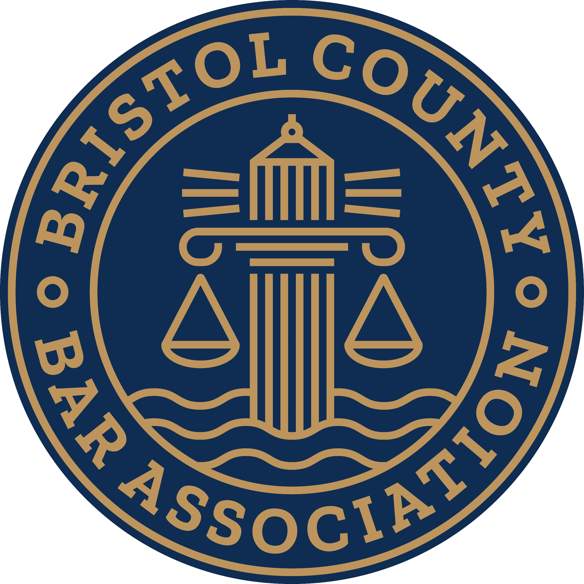
Bristol County Bar Association
448 County Street, New Bedford, MA 02740
508.990.1303
bristolbarassn@gmail.com
2025 MEMBERSHIP DUES
Name:____________________________________________________
First Middle Last
Firm Name:________________________________________________
Business Address:___________________________________________
Phone:_________________Cell:________________Fax:____________
Email:_____________________________________________________
________Dues $175.00/yr. for attorneys
________Dues $100.00/yr. for public interest attorneys (i.e.: Legal Aid; Bar Advocates, etc.) + retired Judges
________Law Students = FREE
________Newly admitted attorneys (first year free) __________________________________________________________
_________Lawyer Referral Service (application available) $100.00/year
(Unique opportunity to have our office field calls and provide referrals. Additional materials to be provided.)
___________________________________________________________
Payment: please mail check or complete credit card info:
Credit card #__________________ exp. date_______cvv#_______zip______
Thank you for your support of the BCBA – we appreciate it!

